P.Vidya Bharathi_Wipro Training_Batch(3)_Satinnder

Day 1 [14-06-2024] – Task 1

* **Differences between dual core and quad core:**

**Dual-Core**processors are those processing units that have two cores. A core is like a processing part that can complete a single time at a point in time so dual-core means that processing can be done at a faster rate. Dual-core processing systems allow performing more than one function at a time.

**Quad-Core** processors are those processing systems that have four cores so it is capable of performing a number of tasks at the same time means it provides the power of parallel processing. These processing systems are much faster than any other processing system.

Following is a table of differences between Dual Core and Quad Core Processors:

|  |  |  |
| --- | --- | --- |
|  | **Dual-Core** | **Quad-Core** |
| 1. | It consists of 2 cores, each designated to perform a specific task. | It consists of 4 cores which give the ability to perform multiple jobs concurrently. |
| 2. | Resource-efficient as it uses less power as compared to Quad-core systems. | Resource utilization is more as compared to dual-core because the number of cores is more. |
| 3. | The clock speed and computation capability are slower than Quad-core. | It is much faster than dual-core systems and computational efficiency is high. |
| 4. | Parallel processing capability is not available in these processors. | It has 4 cores which give it the capability of parallel computing. |
| 5. | The graphic support of the dual-core system is weak and it cannot run heavy graphics. | The graphic support of the quad-core system is high and it is used to run heavy graphics. |
| 6. | The hardware of these processors does not get heated as they produce little heat. | Heat ejection is high and due to this, these processors make the hardware gets heated. |
| 7. | The performance of dual-core processing systems is good. | The performance of dual-core processing systems is better. |
| 8. | Not good for tasks like video editing or animations. | Easily handles the task of video editing and animations. |

* **Difference between Intel Core i5 and i7**
* Corei5 processors use the DMI bus type, while Corei7 uses the QPI bus type.
* Core i5 Processor is dual-core or quad-core, whereas Core i7 processor is dual-core, quad-core, and hex-core processor architectures.
* Hyper-Threading is not possible in Core i5 processors, but it is possible in Core i7 processors.
* The clock speed of Core i5 is 1.2-3.6 GHz, while the clock speed of corei7 is 1.3-3.5 GHz.
* size of Core i5 is 3MB-6MB. On the other hand, the cache size of Core i7 is 4MB-8MB.
* The battery of the Core i5 processor last for 14 hours and 45 but the battery of the Core i7 processor last for 10 hours and 49 minutes.
* i5 processors offer embedded options, but i7 processor does not offer an embedded option.

Day 2 [17-06-2024] – Task 1

**Binary To Decimal Conversion**

**128 64 32 16 8 4 2 1 = Answers**

1 0 0 1 0 0 1 0 = 146

0 1 1 1 0 1 1 1 = 119

1 1 1 1 1 1 1 1 = 255

1 1 0 0 0 1 0 1 = 197

1 1 1 1 0 1 1 0 = 246

0 0 0 1 0 0 1 1 = 19

1 0 0 0 0 0 0 1 = 129

0 0 1 1 0 0 0 1 = 49

0 1 1 1 1 0 0 0 = 120

1 1 1 1 0 0 0 0 = 240

0 0 1 1 1 0 1 1 = 59

0 0 0 0 0 1 1 1 = 7

**Decimal To Binary Conversion**

**128 64 32 16 8 4 2 1 = 255**

1 1 1 0 1 1 1 0 = 238

0 0 1 0 0 0 1 0 = 34

0 1 1 1 1 0 1 1 = 123

0 0 1 1 0 0 1 0 = 50

1 1 1 1 1 1 1 1 = 255

1 1 0 0 1 0 0 0 = 200

0 0 0 0 1 0 1 0 = 10

1 0 0 0 1 0 1 0 = 138

0 0 0 0 0 0 0 1 = 1

0 0 0 0 1 1 0 1 = 13

1 1 1 1 1 0 1 0 = 250

0 1 1 0 1 0 1 1 = 107

1 1 1 0 0 0 0 0 = 224

0 1 1 1 0 0 1 0 = 114

1 1 0 0 0 0 0 0 = 192

**Address Class Identification**

**Address Class**

10.250.1.1 A

150.10.15.0 B

192.14.2.0 C

148.17.9.1 B

193.42.1.1 C

126.8.156.0 A

220.200.23.1 C

230.230.45.58 D

177.100.18.4 B

119.18.45.0 A

249.240.80.78 E

**Network Addresses**

Using the IP addres and suubnet mask shown write out the network address

188.10.18.2

255.255.0.0 188.10.0.0

10.10.48.80

255.255.255.0 10.10.48.0

192.149.24.191

255.255.255.0 192.149.24.0

150.203.23.19

255.255.0.0 150.203.0.0

10.10.10.10

255.0.0.0 10.0.0.0

186.13.23.110

255.255.255.0 186.13.23.0

223.69.230.250

255.255.0.0 223.69.0.0

200.120.135.15

255.255.255.0 200.120.135.0

**Host Addresses**

Using the IP addres and suubnet mask shown write out the host address

188.10.18.2

255.255.0.0 0.0.18.2

10.10.48.80

255.255.255.0 0.0.0.80

222.49.49.11

255.255.255.0 0.0.0.11

128.23.230.19

255.255.0.0 0.0.230.19

10.10.10.10

255.0.0.0 0.10.10.10

200.113.123.11

255.255.255.0 0.0.0.11

223.169.23.20

255.255.0.0 0.0.23.20

**Default Subnet Masks**

Write the correct default subnet mask for each of the following addresses:

177.100.18.4 255.255.0.0

119.18.45.0 255.0.0.0

191.249.234.191 255.255.0.0

223.23.223.109 255.255.255.0

10.10.250.1 255.0.0.0

126.123.23.1 255.0.0.0

223.69.230.250 255.255.255.0

192.12.35.105 255.255.255.0

77.251.200.51 255.0.0.0

189.210.50.1 255.255.0.0

88.45.65.35 255.0.0.0

128.212.250.254 255.255.0.0

/8 - 255.0.0.0

/9 - 255.128.0.0

/10 - 255.192.0.0

/11 - 255.224.0.0

/12 - 255.240.0.0

/13 - 255.248.0.0

/14 - 255.252.0.0

/15 - 255.254.0.0

/16 - 255.255.0.0

/17 - 255.255.128.0

/18 - 255.255.192.0

/19 - 255.255.224.0

/20 - 255.255.240.0

/21 - 255.255.248.0

/22 - 255.255.252.0

/23 - 255.255.254.0

/24 - 255.255.255.0

/25 - 255.255.255.128

/26 - 255.255.255.192

/27 - 255.255.255.224

/28 - 255.255.255.240

/29 - 255.255.255.248

/30 - 255.255.255.252

/31 - 255.255.255.254

/32 - 255.255.255.255

Day 3 [18-06-2024] – LabTask 1

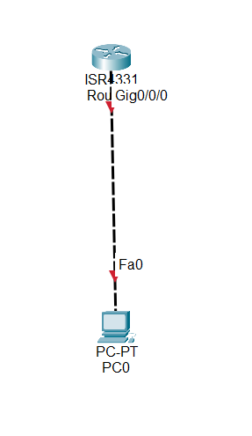

Router to PC connection in Cisco Packet Tracer.

Lab Task 2:

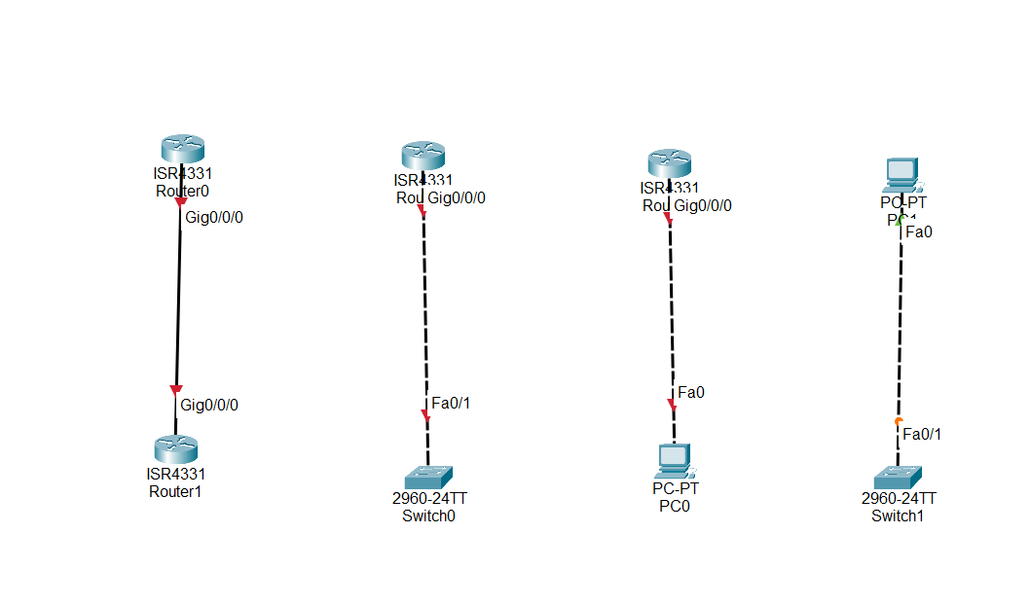1.Router to Router connection

2.Router to Switch connection

3.Router to PC connection

4.Pc to Switch connection

Task 3:

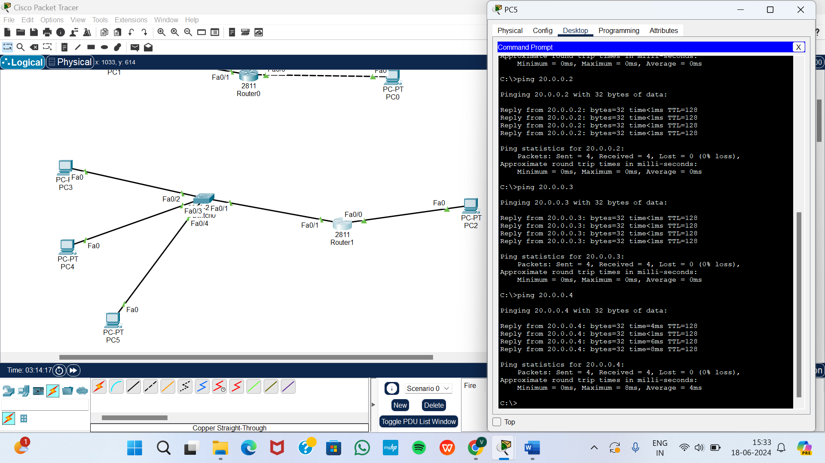

Task 4:

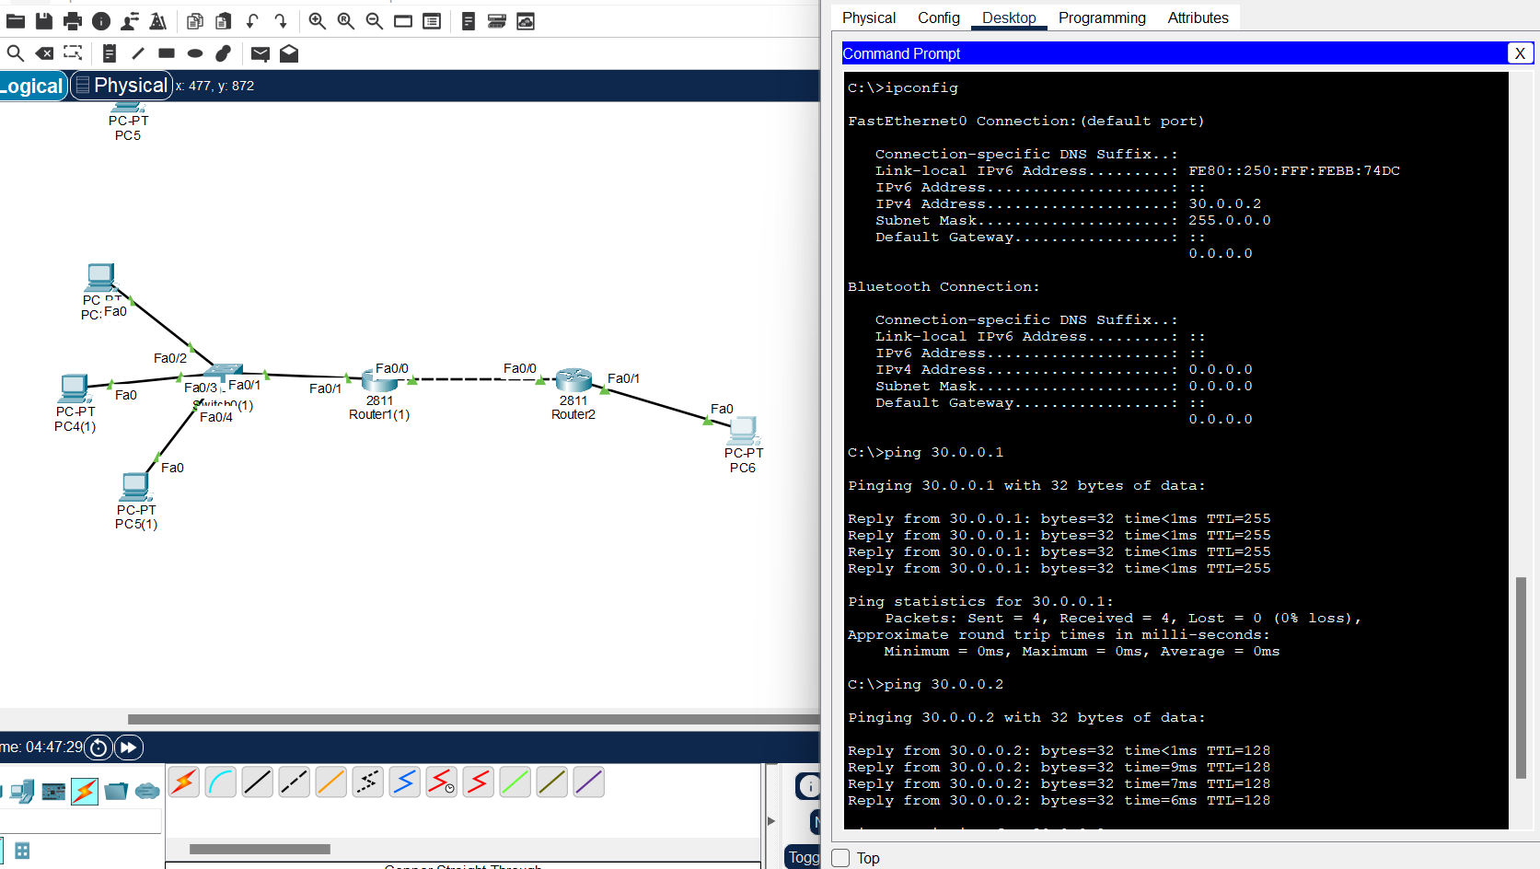

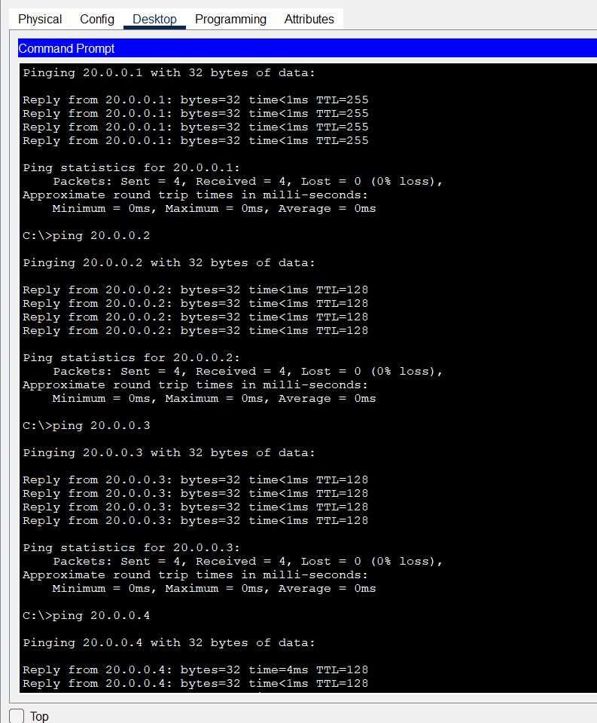

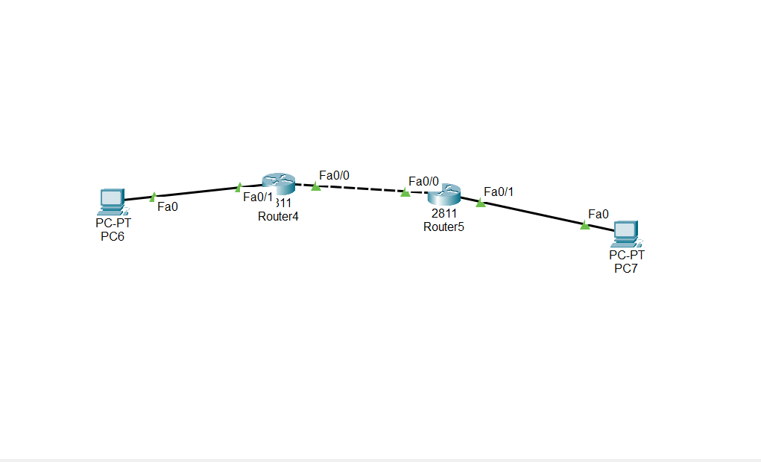Day 4 [19-06-2024] – LabTask 1



|  |  |
| --- | --- |
| PC1 – fa0 | 20.0.0.2 |
| R1 – fa0/1 | 20.0.0.1 |
| R1 – fa0/0 | 10.0.0.1 |
| R2 – fa0/0 | 10.0.0.2 |
| R2 – fa0/1 | 30.0.0.1 |
| PC2 – fa0 | 30.0.0.2 |

|  |  |  |  |  |
| --- | --- | --- | --- | --- |
|  | R1 fa0/1 | R1 fa0/0 | R2 fa0/0 | R2 fa0/1 |
| PC1 | connected | Connected  (default gateway) | Not connected | Not connected |
| PC2 | Not connected | Not connected | Connected (default gateway) | Connected |

LabTask 2 (Static Routing)

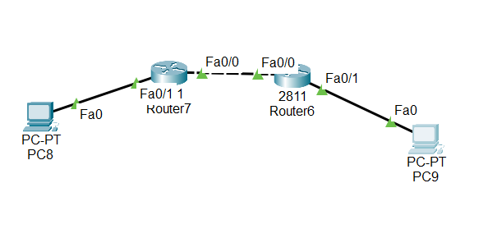

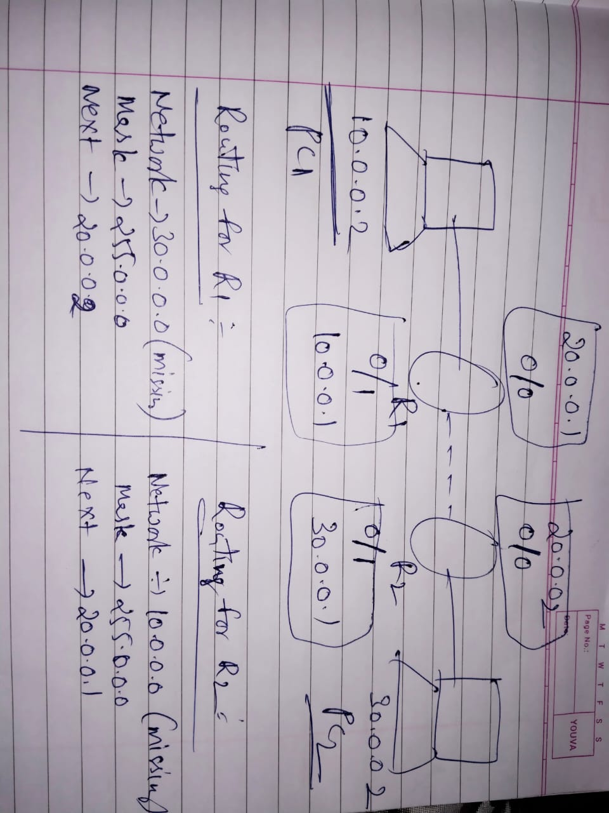

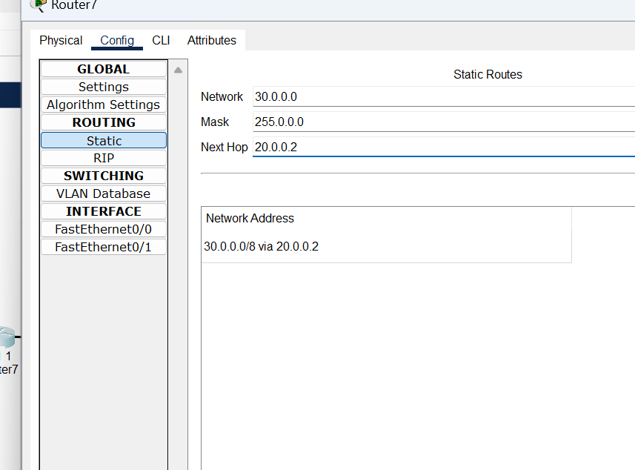

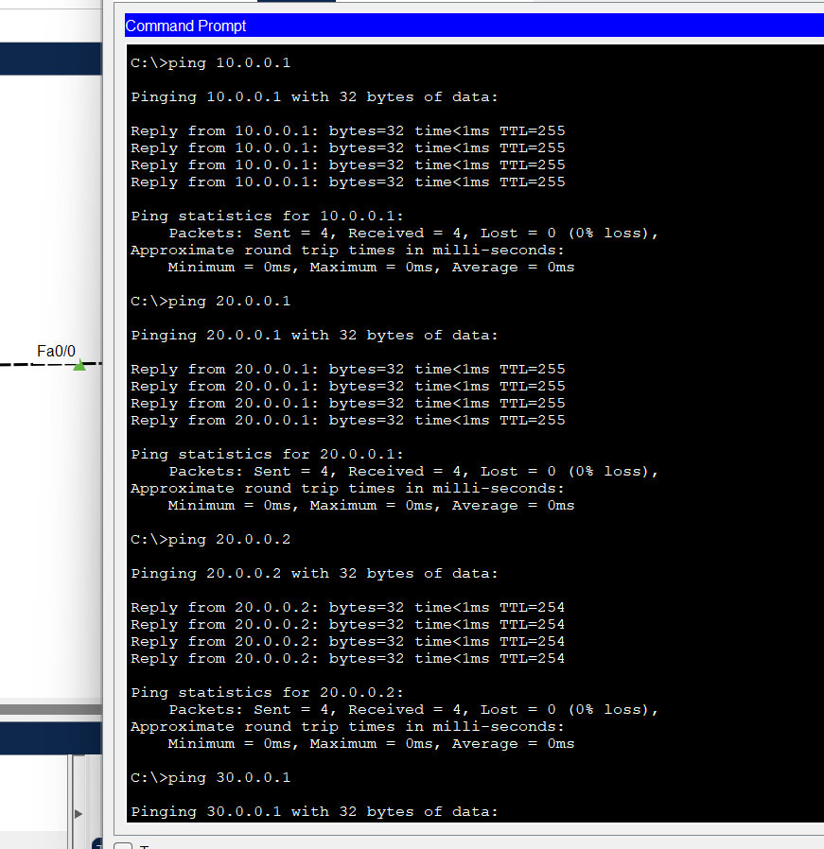

By the process of Routing, we can able to ping all the

ip addresses of each and every router and PCs from both the PCs.

|  |  |  |  |  |  |  |
| --- | --- | --- | --- | --- | --- | --- |
|  | R1 fa0/1 | R1  fa0/0 | R2  fa0/0 | R2  Fa0/1 | PC1 | PC2 |
| PC1 | Connected | connected | connected | connected | connected | connected |
| PC2 | Connected | Connected | Connected | Connected | Connected | Connected |

Day 5 [20-06-2024] – Task 1

OSI Model

Application Layer

Presentation Layer

Session Layer

Transport Layer

Network Layer

Data Link Layer

Physical Layer

| **Layer** | **Name** | **Function** | **Protocols** |
| --- | --- | --- | --- |
| Layer 7 | Application | To allow access to network resources. | SMTP, HTTP, FTP, POP3, SNMP |
| Layer 6 | Presentation | To translate, encrypt and compress data. | MPEG, ASCH, SSL, TLS |
| Layer 5 | Session | To establish, manage, and terminate the session | NetBIOS, SAP |
| Layer 4 | Transport | The transport layer builds on the network layer to provide data transport from a process on a source machine to a process on a destination machine. | TCP, UDP |
| Layer 3 | Network | To provide internetworking. To move packets from source to destination | IPV5, IPV6, ICMP, IPSEC, ARP, MPLS. |
| Layer 2 | Data Link | To organize bits into frames. To provide hop-to-hop delivery | RAPA, PPP, Frame Relay, ATM, Fiber Cable, etc. |
| Layer 1 | Physical | To transmit bits over a medium. To provide mechanical and electrical specifications | RS232, 100BaseTX, ISDN, 11. |

**TCP/IP Model**

TCP/IP stands for Transmission Control Protocol/Internet Protocol. It has 4 layers named as Physical layer, Network layer, Transport layer, and Application layer.  It also can be used as a communications protocol in a private computer network. It was designed by Vint Cerf and Bob Kahn in the 1970s.

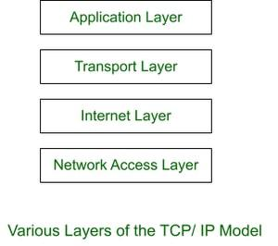

**OSI Model and TCP/IP Model**

**OSI Model TCP/IP Model**

Application Layer

Application Layer

Presentation Layer

Network Access Layer

Internet Layer

Transport Layer

Application Layer

Data Link Layer

Network Layer

Transport Layer

Session Layer

**OSI Model vs TCP/IP Model**

**Differences between OSI Model and TCP/IP Model :**

| **OSI Model** | | **TCP/IP model** |
| --- | --- | --- |
| 1. OSI model provides a clear distinction between interfaces, services, and protocols. | | **1.**TCP/IP doesn’t offer any clear distinguishing points between services, interfaces,  and protocols. |
| 1. OSI uses the network layer to define routing standards and protocols. | **2.**TCP/IP uses only the Internet layer. |
| 1. OSI model use two separate layers physical and data link to define the functionality of the bottom layers | | **3.**TCP/IP uses only one layer (link). |
| 1. OSI model, the transport layer is only connection-oriented. | | **4.**A layer of the [TCP/IP model](https://www.guru99.com/tcp-ip-model.html) is both connection-oriented and connectionless. |
| 1. In OSI model, data link layer and physical are separate layers. | | **5.**In TCP data link layer and physical layer are combined as a single host-to-network layer. |
| 1. The minimum size of the OSI header is 5 bytes. | | **6.**Minimum header size is 20 bytes. |

**Port Numbers**

When TCP or UDP are used to establish communication, the communication is assigned a **port** as the Layer 4 address. A port is a logical assignment given to processes and their respective application protocols on a computing system. A few important facts to memorize about ports are:

* There are 65,535 valid port numbers available to assign to a communication process.
* Ports 0 - 1023 are **Well-Known Ports**: Assigned to universal TCP/IP application protocols. These protocols are the most common such as HTTPS, SSH, FTP, DNS, and the list goes on. They are registered to these protocols by a global
* Ports 1024 - 49,151 are **Registered Ports**: Reserved for application protocols that are not specified as universal TCP/IP application protocols.
* Ports 49,152 - 65,535 are **Private/Dynamic Ports**: These ports may be used for any process without the need to register the port with the global assigning authority.
* When TCP and IP are used together, a Layer 4 port and a Layer 3 IP address are assigned to the connection. This is called a socket. For example, 8.8.8.8:443 is a socket indicating that communication to IP address 8.8.8.8 is to connect to port 443 on the server.
* Application Layer (Layer 7)

Function: Provides network services directly to end-users and applications.

Examples: HTTP, FTP, SMTP, SNMP (Simple Network Management Protocol).

**Port Numbers:**

|  |  |
| --- | --- |
| Protocol | Port number |
| FTP Data | 20 |
| FTP Control | 21 |
| Telnet | 23 |
| SMTP | 25 |
| DNS | 53 |
| HTTP(non secure) | 80 |
| POP3 | 110 |
| IMAP | 143 |
| HTTPS(secure) | 443 |

Lab Task – 1:

